AI Images Are Plugging the Data Void — What’s Next?

Yiren Lu

Class of 2025

Advisor: Danielle Ivory

**AI Images Are Plugging the Data Void — What’s Next?**

#### **Unleashed AI Flood and Disappointing Detectors**

On July 10, 2025, the White House posted an image, generated by Artificial Intelligence (known as AI), reimagining President Donald Trump as Superman on [X.](https://x.com/whitehouse/status/1943493150644777199) His face was seamlessly grafted onto actor David Corenswet’s muscular frame, and the original tagline, “Look Up,” was replaced with a bold, capitalized slogan: “TRUTH, JUSTICE AND THE AMERICAN WAY.”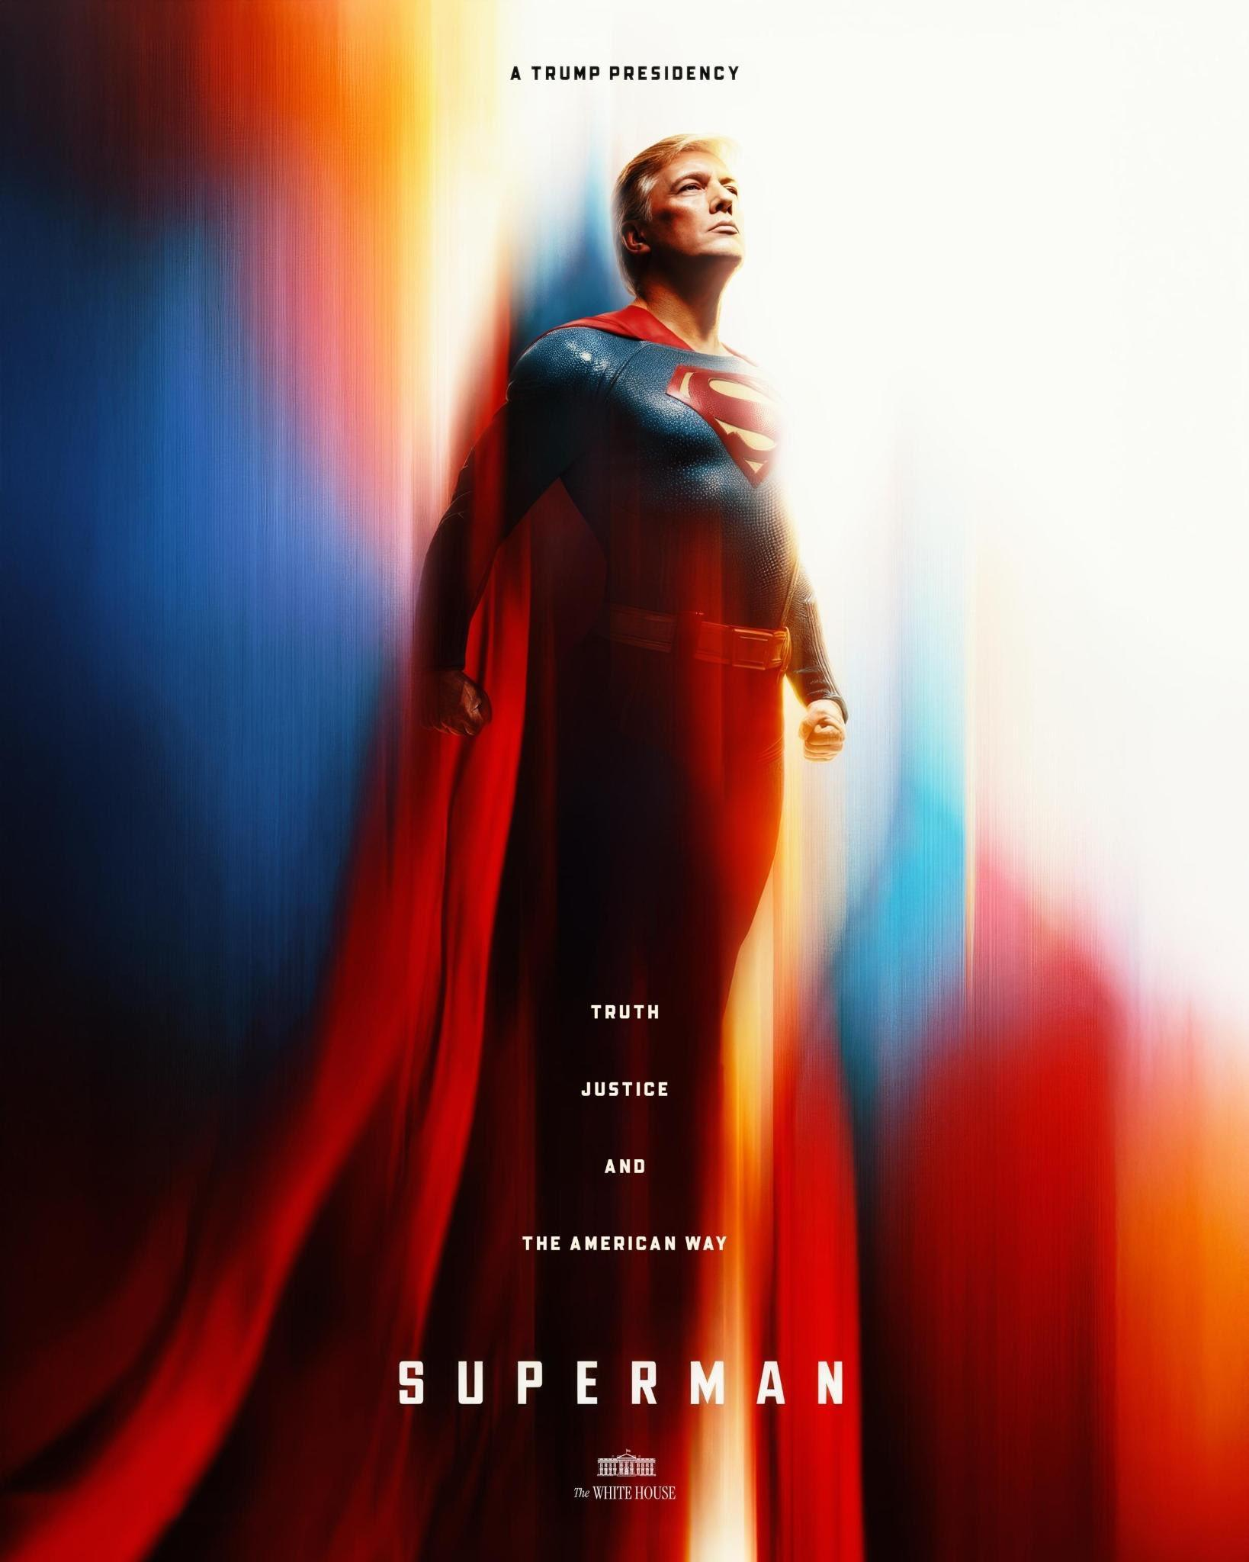

It garnered more than 54.5 million views and was reposted over 3,400 times.

Trump has become the first U.S. president to lean heavily on social media and artificial intelligence as central tools of political messaging — and notably, the White House under his administration has amplified this brand of hyper-stylized propaganda.

When Trump shared another AI-crafted image of himself as the Pope on May 2, 2025, the White House quickly reposted it to its official [X account](https://x.com/WhiteHouse/status/1918502592335724809), where it racked up 110.4 million views and was reposted 53,000 times.

And these images are swarming search engines, too, fueled by Trump’s enormous online influence, the official White House repost, and massive media coverage. A Google Image search for “Trump Pope” now turns up mostly AI-generated pictures of Trump dressed as the pontiff, either the fake image itself or screenshots of the White House’s post. When searching “Trump superman” on Google Images, the results include not only the fake images shared by the White House’s X account but also links to merchandise such as T-shirts and hats portraying Trump as Superman.

With the fast blooming of generative AI across the internet, complaints of fake images in search engines have been emerging.

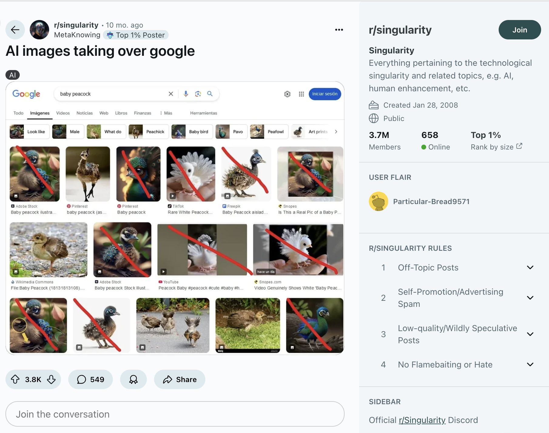

Reddit complaints about AI images taking over google image search

On Reddit, a thread discussing [how AI images have flooded Google Image search results](https://www.reddit.com/r/singularity/comments/1fyf93x/ai_images_taking_over_google/) has over 3.8k votes and over 500 discussions, with most comments complaining of the pervasiveness of fake images. In May 2024, [researchers](https://arxiv.org/pdf/2405.11697) from Google and Duke University Reporters Lab released a report studying a total of 135,838 pieces of misinformation dated back to 1995, and found that about 80% of the misinformation content involved media. The bulk of the content appeared after the ClaimReview Project, a project aiming to fact-check and identify information online, was introduced in 2016.

Interestingly, a drastic change happened in the composition of the misinformation studied in the spring of 2023. When the [fake photo of Pope Francis](https://www.nbcnews.com/tech/pope-francis-ai-generated-images-fool-internet-rcna76838) went viral, a surge in AI generated images appeared, like the opening of a pandora box. In the following August, San Francisco filed the first [lawsuit](https://www.npr.org/2024/08/16/nx-s1-5078574/san-francisco-lawsuit-goes-after-websites-that-create-sexually-explicit-deepfakes) against websites that used AI to create pornographic deepfakes in history, ringing the alarm against rising generative AI media.

However, none of these seemed to slow down the flourishing of synthetic media. According to [Everypixel Journal,](https://journal.everypixel.com/ai-image-statistics) an estimated 34 million AI images have been created per day since the introduction of DALLE-2, a text-to-image model developed by OpenAI in 2022.

To measure the reach of this new technology, a Columbia University Journalism School reporting project analyzed 10,475 images pulled from Google, DuckDuckGo and Bing. The findings reveal a broader trend: AI-generated media is increasingly filling gaps in image libraries, and its echoes are especially loud within political discourse.

The reporting focused on the prevalence of AI-generated images in search engine photo and picture databases. Columbia conducted comparative tests to compare the percentage of AI-generated media retrieved by popular search engines, including Google Images, DuckDuckGo, and Bing Image Search.

Columbia first examined images based on 2024 [Google Trends](https://trends.google.com/trends/explore?date=2024-01-01%202024-12-31&hl=en) data on rising searches across Google-defined categories, including Arts & Entertainment, Autos & Vehicles, Beauty & Fitness, Books & Literature, Business & Industrial, Computers & Electronics, Finance, and others.

Despite slight variance in the outcomes, the search engines all demonstrated a minimum level of AI-generated content in the image search results.

Columbia then collected URLs of 8,174 images in total from Google, DuckDuckGo, and Bing, and examined them through a free AI image detector on Hugging Face, an open-sourced model hub for artificial intelligence, in conjunction with a manual check, identifying images with AI scores higher than 0.5 as ‘fake’.

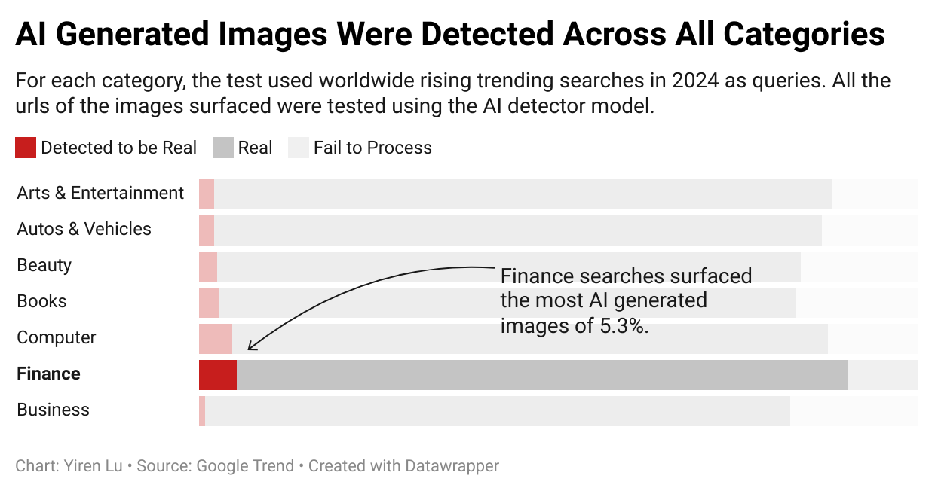

The Hugging Face model, Hive and Sightengine’s AI image detectors all showed significant limitations when dealing with low-resolution images and performed less accurately compared to human detection. For example, when DuckDuckGo pulled the famous AI generated images of ‘Trump being chased by the NYPD’, sightengine, deepfake detector of Hive and the model I chose on Hugging face all failed to identify the AI content.

Search engines could not inform the users about what they may be looking at either.

Current search engines usually lack the system to distinguish AI content or to notify the audience of the potential risks. AI images are showing up in image search engines without warnings or effective labeling by the platforms, contaminating the online database with a new type of cyber pollution.

**Fake Image**

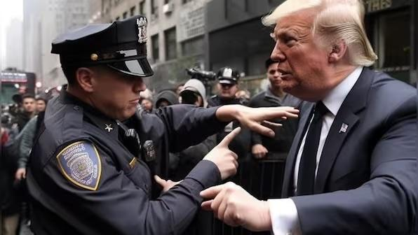

**Test Results from an AI generated image of Trump**



**Sightengine**

**Hive (NVIDIA version)**

**Hive Moderation**

**Fake Image**

**Fail to detect**

**Fail to detect**

**Fail to detect**

The [New York Times](https://www.nytimes.com/interactive/2023/06/28/technology/ai-detection-midjourney-stable-diffusion-dalle.html), [Bellingcat](https://www.bellingcat.com/resources/2023/09/11/testing-ai-or-not-how-well-does-an-ai-image-detector-do-its-job/) and many other media have repeatedly tested how AI detectors can be fooled, and have found that, despite rapid progress in developing new detection tools, both open-source models and commercial detectors have shown notable shortcomings when confronted with fake images.

In the absence of consistent guidelines and regulations, and due to current limitations in content detection technologies, these spaces risk amplifying misinformation by reinforcing visual narratives rooted in falsehoods.

“Open-source models exist for detecting deepfakes, but their results are probabilistic,” [Papakyriakopoulos](https://www.professoren.tum.de/en/papakyriakopoulos-orestis) said. “For instance, a model might estimate a 30% likelihood that an image is a deepfake. That’s why it's recommended to use multiple detection models to reach a more reliable conclusion.”

After sharing these concerns with [Orestis Papakyriakopoulos](https://www.professoren.tum.de/en/papakyriakopoulos-orestis), Societal Computing Professor at Technical University of Munich, Columbia decided to combine different tools to cross test the validity of the results by comparing the detecting results of NVIDIA's free Hive model and Sightengine’s AI image detector.

Despite that, the detectors and models still failed the detecting tasks. They demonstrated weaker performance in discerning reality compared to the human eye.

#### **AI Takeover of Data Voids in Political Debate**

The ‘Trump Arrested’ series went viral on the Internet in 2023. The picture is one of a series of Donald Trump being chased and arrested by the New York Police Department. M[any media outlets](https://www.bbc.com/news/world-us-canada-65069316) covered this deep fake picture and its phenomenal circulation.

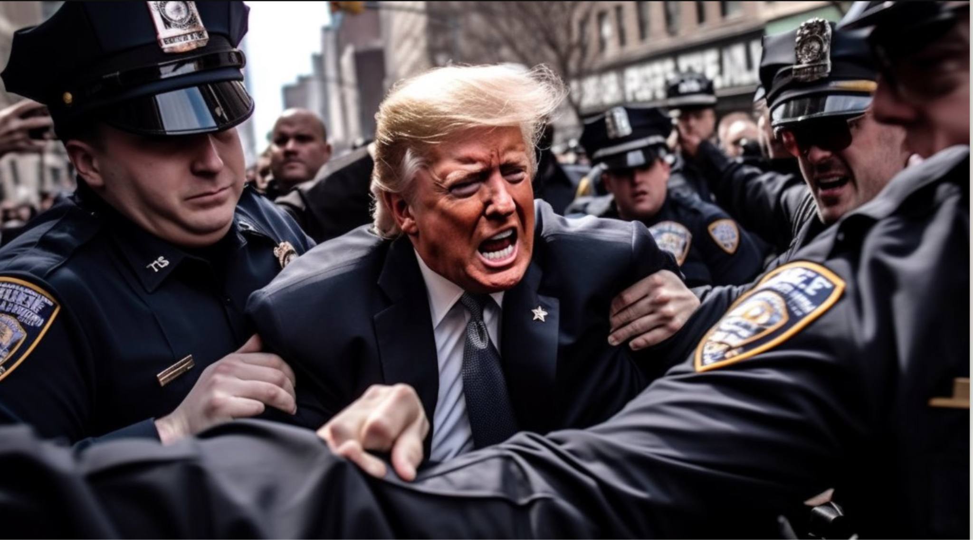

AI generated image of ‘Trump being arrested’

The famous series also popped up in Columbia’s search experiment. DuckDuckGo found the AI-generated picture of Trump being arrested by the police when the Columbia reporting project used the query ‘Donald Trump.’

According to reporting from Columbia, DuckDuckGo had the highest number of fake images among the platforms studied. By taking a closer look at the AI-generated images found, Columbia noticed that many of them shared the same domain of [https://i.ytimg.com/vi/](https://i.ytimg.com/vi/dHlsPkwJ2-U/maxres2.jpg?sqp=-oaymwEoCIAKENAF8quKqQMcGADwAQH4Ac4FgAKACooCDAgAEAEYZSBeKFAwDw==&rs=AOn4CLBgBx94zcZlkPvzIzsFrFU2Pyshqg), which means they all came from the video image thumbnails on YouTube. Another example pulled with the query ‘Donald Trump’ featured a woman standing in front of an AI image of a baby with features similar to the 45th and 47th president of the US.

These visual expressions are an emerging but growing force in political debate and may be closely tied to shifts in public opinion and political campaigns. In [a study](https://arxiv.org/html/2402.14947v1) by Colby College, Kennesaw State University, and [Notre Dame, researchers](https://news.nd.edu/news/experts-say-politically-salient-imagery-on-social-media-can-be-a-predictor-of-political-instability-and-violent-conflict/) found that circulations and creations of political memes, both text and visual-based, can be predictors of political violence. In their study of the war in Ukraine, scientists monitored military bloggers’ posts prior to Russia’s invasion and observed an 5,352% increase in images posted before it occurred.

Through image reverse search, Columbia found that the clip of ‘Baby Trump’ was generated by a commercial synthetic video generation platform called [lilwhipersnappers.com](http://lilwhipersnappers.com). The site posted the video of an AI-generated baby featuring characteristics of Donald Trump on its Instagram page, and then the image was reposted to YouTube Shorts.

The Harvard Kennedy School Misinformation Review, a peer-reviewed scholarly publication, released a study on Jan. 30, 2025, about AI in the 2024 U.S. presidential election, stating that four out of five Americans surveyed were concerned about AI’s increasing presence in the election.

News Media like [NPR](https://www.npr.org/2024/10/18/nx-s1-5153741/ai-images-hurricanes-disasters-propaganda) and [Guardian](https://www.theguardian.com/science/2024/sep/12/ai-can-change-belief-in-conspiracy-theories-study-finds) have also called attention to the use of AI images to incite public emotions or to even manipulate public opinions in relation to politics and social events.

Columbia conducted another experiment to study the intersection of AI and public opinion about politics and celebrities, examining images of the top searched people in the United States. For this analysis, Columbia used the top 10 most searched individuals in the United States in 2024 including Donald Trump, Kamala Harris, JD Vance, Joe Biden, Catherine Princess of Wales, Tim Walz, Mike Tyson, Jill Stein, Usher, and Imane Khelif.

Using DuckDuckGo API for DuckDuckGo image search results, and Serp API for Bing image and google image search results, Columbia compared the results of the three big platforms. The dataset includes 1000 results from Google Image, 684 for DuckDuckGo, and 617 for Bing Image search. The URLs were examined by two AI image detection algorithms – Sightengine and NVIDIA's free version of Hive Model. The results were cross-tested to ensure preciseness.

Surprisingly, despite widespread complaints about AI-generated images — such as overly stylized animals — flooding general image search results, Google Images performed exceptionally well in people-related searches. Neither detection model identified any apparent synthetic images among the 1,000 reviewed. In comparison, DuckDuckGo showed an average AI-generated image rate of 1.23%, based on the combined predictions of the Sightengine and Hive models. For Bing Image Search, the average was lower, at approximately 0.44%.

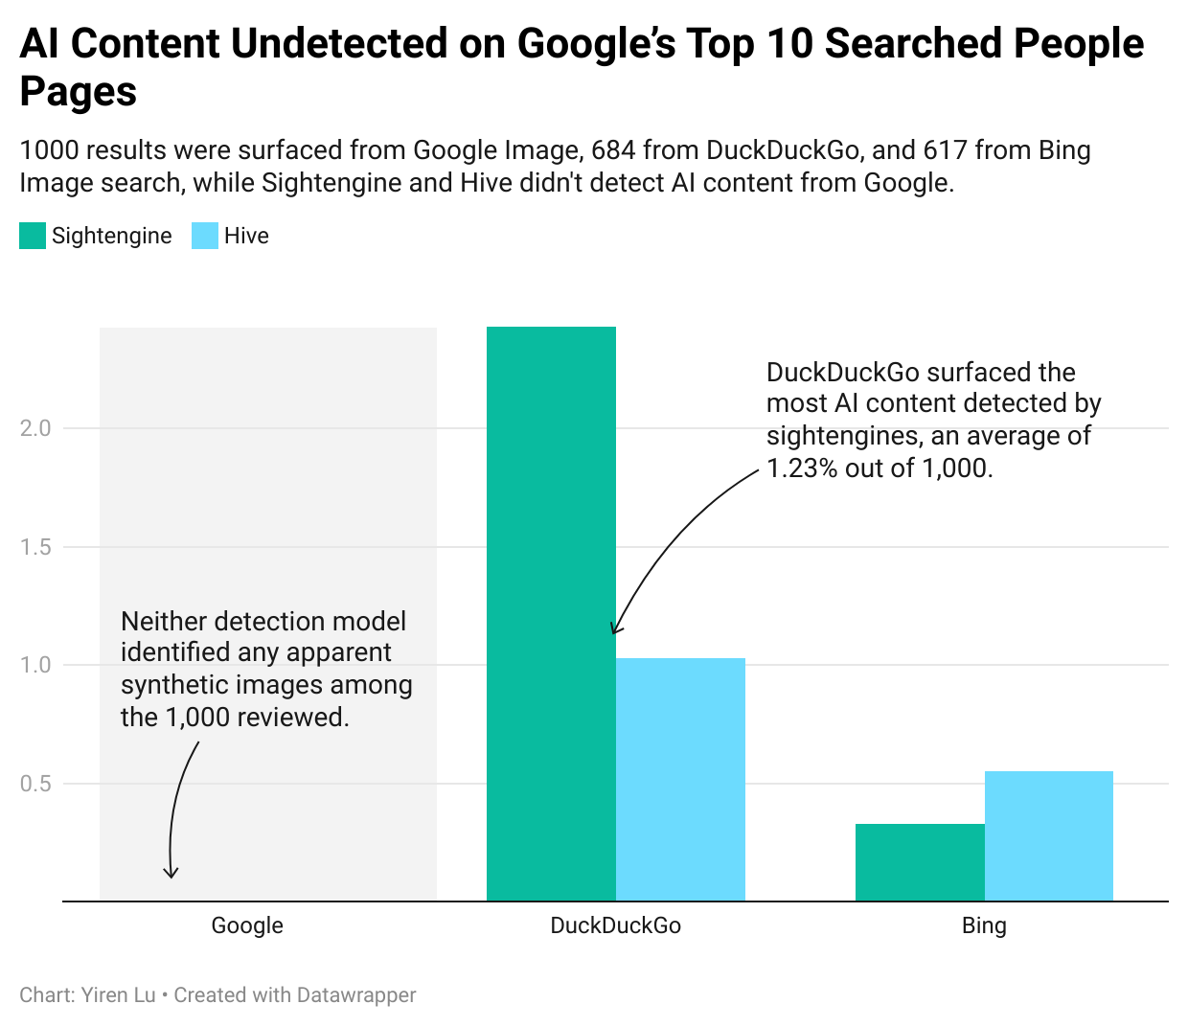

However, that system broke down quickly when the searches veered beyond simple queries with names. The percentage of AI-generated content increased significantly when Columbia used queries with a political bent or themes invoking popular memes and conspiracy theories.

A Columbia reporter used a customized scraper to download the results with selected queries The results were also analyzed manually. For example, Google didn’t show much synthetic content on the research result page in response to the query ‘Donald Trump.’ But in response to the query ‘Trump muscular’, about 70 out of 286 images retrieved contained fake images. Many of them were directly related to Donald Trump’s social media content, which has frequently displayed AI-generated content that depicts the president as physically tough. One famous photo shows an image of Trump as the movie character, Rocky. 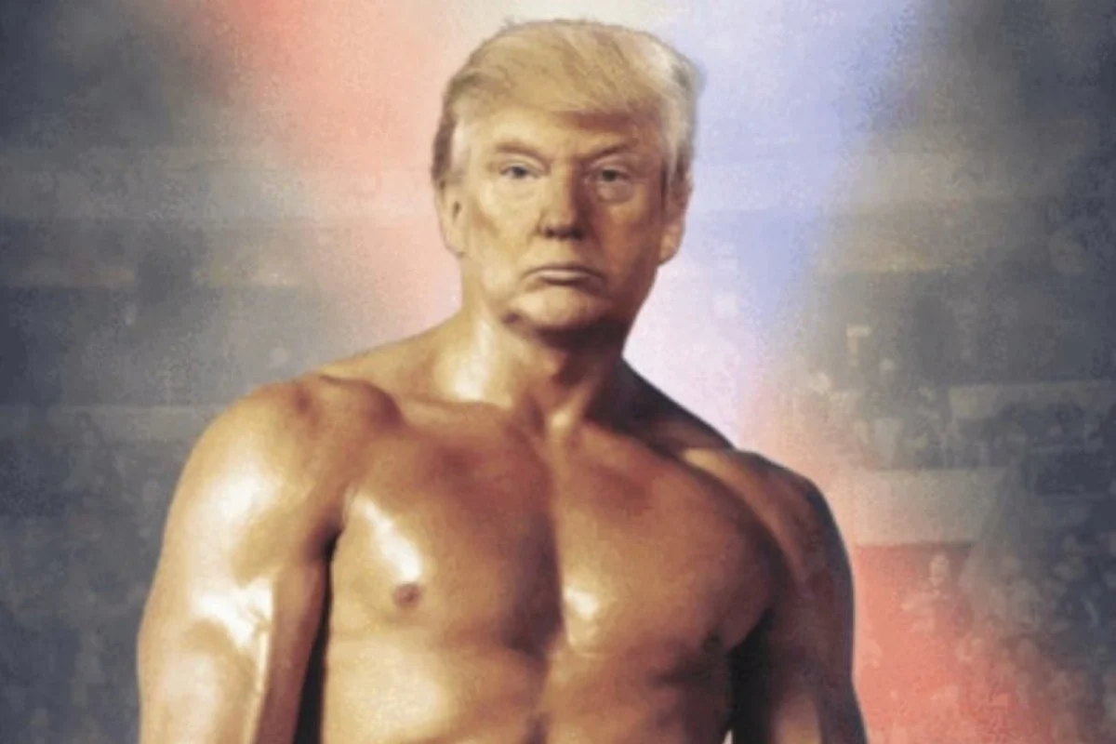

Using the same query structure for Joe Biden, Columbia found that, out of 322 images, 48 were either fully AI-generated or contained obvious AI elements. Most of these images appeared to come from generative AI tools such as Stable Diffusion and Craiyon.

Searches for Vice President Kamala Harris and conspiracy theories associated with her yielded few clearly AI-generated images across major search engines. One notable example circulating online depicted Harris as a McDonald’s employee, a doctored image widely available on platforms like Stable Diffusion Online. The image may reference past political jabs involving her part-time work history and criticism from former President Donald Trump. Additionally, many AI-generated images of Harris featured exaggerated facial expressions in a satirical style. A recurring theme involved distorted images of her laughing, with variations of the same profile appearing across multiple AI image generators.

Columbia also used a scraper to extract the video thumbnails from the first 20 pages of YouTube and collected 749 pictures, and 220 on Rumble. Hive didn’t detect apparent AI generated images from these thumbnails, but 10 synthetic images of ‘Joe Biden’ were pulled from Rumble. In the image, Joe Biden stands stiff and upright against the backlight, his face obscured. On both sides of him are human-like figures with similar builds, resembling countless cloned copies of Alice from *Resident Evil*. The caption says “BIDEN CLONE DOUBLES + ROBOTIC SOULESS ENTITIES” at the top, hinting towards the conspiracy theory of Biden being a cloned entity.

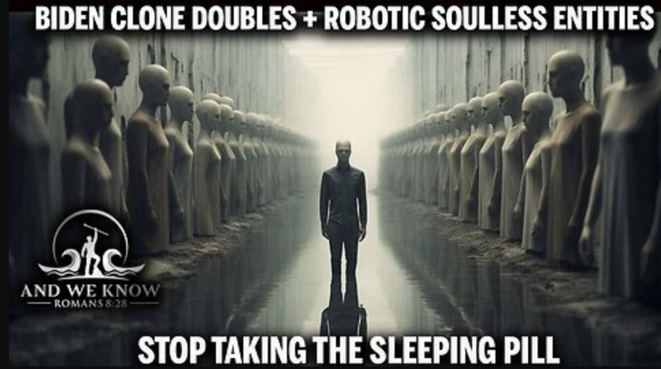

AI generated Joe Biden meme found on Rumble

When reached for comment, Google replied in email that their algorithm ranks content based on relevance, which often results in the most recent news coverage being prioritized. In contrast, when there is a scarcity of related content, a phenomenon known as a “data void”, user-generated AI images can surface instead.

According to Google, the company’s algorithm prioritizes credible, high-quality sources in their results.

Some experts said that AI-generated visuals have opened a new frontier in political communication and artistic expression. Like memes or political cartoons, these images are sharp, viral, and able to distill complex issues into eye-catching visuals—except now, anyone can make them, not just trained illustrators.

Even professional artists see opportunity in this shift.

John Neufeld, the writer and artist of the bestselling nonfiction graphic novel [A.D.: New Orleans After the Deluge](http://www.joshcomix.com/product/a-d-new-orleans-after-the-deluge/) said he believed that some anachronic art forms like political cartoons could be replaced by more simplistic and highly sharable popular art.

“Personally, I feel that the political cartoon per sé is a bit anachronistic and doesn't have much social impact anymore.” Neufeld said in an email. “Those who practice it are quite insightful and clever. I'd like to see if AI-generated cartoons approach their levels of observation and commentary.”

Neufeld said he held a reserved opinion on whether AI could capture the complexity and intricacy as well as human artists could do, but he also said that people using AI to create political memes had become increasingly popular, and political memes often perform well in capturing public attention and generating widespread response.

Politicians are seeing AI as a financially beneficial instrument in their campaigns. Jacob Neiheisel, an associate professor of political science at the University at Buffalo, expressed concerns about this phenomenon.

Neiheisel noted that the rise of generative tools has made political expression more accessible, allowing individuals to create campaign-style content without relying on professional ad agencies. Although distribution still depends on platforms, anyone can produce material with the hope of it going viral. This openness encourages broader participation in political conversation.

But the ease of creation also raises red flags, he said. As political content becomes easier to fake, misinformation risks grow. Neiheisel cautioned that while AI enables more participation, it also boosts the spread of extreme or misleading material. He warned that public trust in all media could decline as people struggle to tell real from fake.

“A major concern is declining public trust,” he said. “As people become aware of AI-generated political content, they may grow more skeptical of all campaign media. While these tools democratize content creation, they risk undermining credibility across the board. It’s a double-edged sword where easier participation comes at the cost of potential widespread distrust.”

He also believed that AI would become increasingly common in future political campaigns, citing Donald Trump’s use of it on his X account as an example, but he pointed out that the actual influence of how traditional and social media can shape the public opinions was questionable.

The professor explained that, while contemporary media is a crucial part of every campaign, it's challenging to prove that campaign ads have major effects. Their influence tends to be limited, often persuading some voters but having less impact on motivating people to act. Overall, campaign media does have measurable effects, but they are generally small.

Zhang Chenliang, Director of China National Geography Multimedia Center and former editor in chief of Journal of Natural History criticized AI generated images and videos on his popular program series [Viral Creature Verified](https://b23.tv/O3cCov3).

Zhang said on his program that he was frustrated by creators who don’t disclose their use of AI, saying he “truly loathe[s] those accounts that post their AI-generated pictures online without informing their audiences,” and that “when you use AI to create your work, you should be responsible for acknowledging it.”



People posting AI generated images on social media pretending to be real photos

He then placed two pictures one after another — one was a hyper-realistic AI image of strawberries spilling from the vines in a cascade; the other a synthetic photo of a vineyard, where clusters of golden grapes draped the sky like a shimmering waterfall and looked gorgeously real. But both pictures were fake.

The picture of the vineyard was posted by a Douyin, Chinese name for TikTok account named “Extraordinary Wheat.” Its caption read, “I was just a few days away from home in Hainan, and my grapes are turning into raisins,” misleading viewers into believing the image was real.

Zhang expressed concern that such images are too misleading and could easily confuse the public. He said on the program that he is worried about the spillover of AI-generated content into large datasets, where original contexts are stripped away—leaving the public with more gaps.

[Papakyriakopoulos](https://www.professoren.tum.de/en/papakyriakopoulos-orestis), the technical University of Munich researcher, agreed.

“AI-generated content could pollute training datasets for future models, degrading their performance if synthetic data dominates,” [Papakyriakopoulos](https://www.professoren.tum.de/en/papakyriakopoulos-orestis) said.

“There’s an increase in AI-generated content pollution, especially on social media. It’s not always used for disinformation, but people often confuse it, leading to misinformation.”

#### **Digital Dilemma–Who’s Accountable?**

If a person mistakes a fake image retrieved from search engines for authentic, should platforms bear any responsibility? While the platform did not create the image, its algorithms surfaced it without clear labeling. Does that amount to overlooking, or even enabling the risk of misinformation?Even experts and scholars haven’t reached an agreement.

Sacha Atlay, a postdoctoral research fellow working on misinformation, trust, and social media in the Digital Democracy Lab at the University of Zurich, believes that it’s not necessary to have a malicious or fraudulent purpose in creating misinformation.

“Researchers mostly use misinformation as an umbrella term.” Atlay said. He pointed out that anything false or misleading that spreads without necessarily the intent to cause harm could fit in this category.

[Hendrik Heuer,](https://hen-drik.de/) research professor at the [Center for Advanced Internet Studies](https://www.cais-research.de/) and the [University of Wuppertal](https://www.uni-wuppertal.de/en/), thinks that although current algorithms and displays of result pages may misinform people, it is not necessarily considered misinformation.

Heuer explained that when studying misinformation, he prefers to define it by separating unintentional false information shared in the wrong context from disinformation, which involves deliberate intent to deceive. In his view, the situation reflects a decline in search quality rather than clear-cut misinformation, although it does have the potential to mislead.

Heuer also said in an interview that without legal constraints or potential economic benefits, counting on the big firms to take the lead and responsibly distinguish authentic photos from synthetic content could be way too idealistic.

“From my European perspective, we need strong laws like GDPR and Digital Services Act to mandate transparency. Companies won't do this voluntarily because it costs money,” Heuer said. “Lawmakers must require transparency about data and energy use so people can make informed choices.”

[GDPR](https://gdpr.eu/) refers to the European Union’s General Data Protection Regulation Compliance, which requires companies to process data in a legal, fair and transparent manner. While it doesn't explicitly refer to AI technologies, it can still be applied to personal data protection against unpermitted training of AI models with users’ data. [The Digital Services Act](https://commission.europa.eu/strategy-and-policy/priorities-2019-2024/europe-fit-digital-age/digital-services-act_en), on the other hand, requires online intermediaries, platforms including search engines to tackle illegal and harmful activities online including disinformation.

Both two acts are European based that have certain degrees of enforcement upon American businesses with a ‘substantial connection' to Europe. The states, by contrast, don't have comprehensive law enforcement regarding AI at the federal level.

And accusing Google Images of spreading misinformation simply for including AI-generated visuals in its results is far from straightforward, experts said.

But neglecting the increasing disputes over misuse of AI generated images and the growing quantity of synthetic media in image search results, they said, seems irresponsible as well.

[Fortune Business](https://www.fortunebusinessinsights.com/ai-image-generator-market-108604) Insight predicted in its AI Image Generator Report that the market size for North America AI Image Generator is projected to grow to USD 917.448 million by 2030. The trend will significantly benefit small-scale businesses, e-commerce, and individual campaigns, with limited resources to be allocated.

With more businesses offering free tools to generate AI images, the likelihood of these images appearing in search engine results has also increased. Meanwhile, experts said, it’s hard to imagine politicians, some of whom are already leveraging AI, moving to curb a tool that they themselves find useful.

“Humans are very visual creatures: it’s just our nature,” said [Kim Lisagor Bisheff](https://www.kcbx.org/people/kim-bisheff), Cal Poly Journalism Professor, reporter at Los Angeles Times and Outside Magazine, in an interview. “If we can figure out how to use these tools responsibly, democratizing the process could be a good thing, especially for people trying to make a difference who don’t have big budgets.”

Cal Poly published an interview with Bisheff on media literacy, focusing particularly on AI education. As both an educator and a media professional, Bisheff didn’t share the widespread fear in the industry that AI threatens creative jobs. Instead, she was afraid that the vulnerable ecosystem of public discourse would not stand the impact of fast blooming AI without legal constraints.

“We have to be careful about transparency and intent,” she said in the interview. “There are big questions: How do we protect the public? How do we teach people to differentiate between real and AI-generated content?”

Bisheff said that she believes the solution doesn’t lie in hoping for sweeping government regulations to set standards and control content. Instead, she argues, the focus should be on strengthening media literacy to help people navigate the changing information landscape.

Many scholars and scientists, including Bisheff, referred to Photoshop as a technology that once challenged the public’s trust in visual media but is now widely used across industries. They noted that people have been creating flawless, heavily edited portraits of celebrities for years, but the public has largely chosen not to view them as misinformation or disinformation.

Atlay agreed with that line of questioning, noting that every major technological shift, whether it was mass printing, photography, the rise of the internet, or now artificial intelligence, has challenged society’s understanding of what counts as credible, trustworthy information.

“I don’t believe generative AIs will have similar power to overturn the way we perceive information as the previous technologies did.” Atlay said.

To Atlay, AI is simply the next evolution of Photoshop—an advanced, user-friendly tool that speeds up the process of creating edited images.

Like Bisheff, he believes the real challenge isn’t the technology itself but teaching people to separate credible sources from the flood of online information.

#### **Methodology**

In this article, fake images refer specifically to AI-generated or synthetic images.

For the initial phase of analysis, a list of search keywords was compiled based on the top rising search terms worldwide in 2024, as reported by Google Trends. Each keyword was queried across three search engines: DuckDuckGo, Google Images, and Bing. The resulting images were collected in the form of thumbnail URLs. These URLs were then evaluated using a freely available AI detection model hosted on Hugging Face (dima806/deepfake_vs_real_image_detection). The model classified the images into three categories: real, fake, and error. A label of real indicated that the model recognized the image as a genuine photograph; fake denoted that the image was identified as AI-generated; and error was assigned when the model was unable to classify the image. Images being labelled as ‘fake’ were manually checked afterwards.

The second phase of the analysis focused on the top ten most searched individuals in the United States, also identified via Google Trends. Each individual’s name was queried across DuckDuckGo, Google Images, and Bing. In this phase, SerpAPI was employed to systematically collect the image URLs returned by these search engines. The collected images were then analyzed using three AI detection models: the dima806 model on Hugging Face, Sightengine, and NVIDIA’s Hive model. Sightengine and Hive were accessed through their official APIs, which generated a confidence score between 0 and 1 for each image, where 0 indicated a real (authentic) image and 1 indicated an image determined to be fully AI-generated. In this study, images with a score above 0.5 were classified as fake images.

An additional test was conducted on thumbnail images retrieved from YouTube and Rumble. Using SerpAPI, the study gathered URLs linking to these thumbnails, prompted by the observation in the second phase that a substantial portion of image URLs—especially on DuckDuckGo—originated from YouTube. These thumbnails were then evaluated using both the Sightengine and NVIDIA Hive models to assess the prevalence of AI-generated content among video platform thumbnails.

The final phase of the analysis involved a manual review centered on three prominent political figures: Donald Trump, Joe Biden, and Kamala Harris. This phase examined images linked to key events during and after the 2024 presidential election, including the assassination attempt on Trump, his public speeches, and related social media posts. Searches were conducted exclusively on Google Images, and the resulting images were downloaded using a custom-built scraper. Each image was then manually examined, and the number of AI-generated images was counted based on human visual inspection.

**Postscript**

AI is a very trendy topic these days, but most discussions of generative AI still revolve around privacy, copyright, or questions of authorship. I was drawn to this topic for a more everyday reason: I’m a frequent user of Pexels and other free image stock sites. Lately, when searching for illustrations or photos to use in my articles, I kept running into huge numbers of fake images — some obvious, some subtle. That sparked a very simple but nagging question in my mind: what percentage of the images we see in an ordinary search are actually synthetic?

To see if this was just my personal frustration or part of a larger pattern, I began reading forum posts where others voiced similar concerns. At the same time, I talked with software developers and computer scientists about the risks of AI-generated visuals. From these conversations and background reading, two major dangers stood out to me: the pollution of data that new AI models rely on for training, and the pollution of information online that could mislead or confuse the public.

My first idea was to document the misuse of fake images, but as I dug deeper, I realized it might be even more revealing to measure how widespread they really are — to put numbers behind an intuition many people share. That’s how I designed a multi-phase study, beginning quite broadly. I started by compiling the top rising search terms worldwide from Google Trends, then examined image results on DuckDuckGo, Google Images, and Bing using an AI detection model. The data confirmed that fake images do show up in common searches. But I soon found this approach too broad to tell a focused story.

Then, one day, I stumbled on a viral set of fake images showing Donald Trump being arrested. That moment shifted my thinking. I became curious about how fake images cluster around figures in the public eye — especially politicians. So, I narrowed my scope and looked at the top ten most searched individuals in the U.S., this time testing the results with three different AI detection models, including official APIs that gave confidence scores. Along the way, I noticed that many search results were actually thumbnails from video platforms, especially on DuckDuckGo. That led me to add an extra test focusing on YouTube and Rumble thumbnails.

Finally, I conducted a manual review of images linked to key moments during and after the 2024 presidential election, focusing on three major political figures: Donald Trump, Joe Biden, and Kamala Harris. I was struck by how both flattering and unflattering fake images appeared around the same person — suggesting AI images aren’t just background noise but sometimes act as an intentional form of political commentary.

What surprised me most in the end wasn’t just the number of fake images, but how casually they show up and how widely they are employed in commercial and political campaigns, even when we search for everyday topics, not only sensational news. Even funny memes we shared on social media are increasing their influences. Through this project, I wanted to move beyond hand-wringing headlines and see what the data could actually reveal about just how deeply synthetic images have blended into what we see when we simply “Google it.”

**Source List**

**Atlay, Sacha**  
 University of Zurich  
 Experimental psychologist working on misinformation, misperceptions, and (dis)trust  
 [sacha.yesilaltay@uzh.ch](mailto:sacha.yesilaltay@uzh.ch)

**Bisheff, Kim Lisagor**  
 Cal Poly  
 Journalism / Assistant professor  
 [klisagor@calpoly.edu](mailto:klisagor@calpoly.edu)

**Farnsworth, Meghann**  
 Google  
 Press  
 [mtfarnsworth@google.com](mailto:mtfarnsworth@google.com)

**Garcia, Colette**  
 Google  
 Press  
 [colettegarcia@google.com](mailto:colettegarcia@google.com)

**Heuer, Hendrik**  
 Center for Advanced Internet Studies & University of Wuppertal  
 AI Computation  
 [hendrik.heuer@cais-research.de](mailto:hendrik.heuer@cais-research.de)

**Neiheisel, Jacob**  
 University of Buffalo  
 Political Science  
 [jacobnei@buffalo.edu](mailto:jacobnei@buffalo.edu)

**Neufeld, Josh**  
 Freelancer  
 Cartoonist/ writer  
 [joshcomix@gmail.com](mailto:joshcomix@gmail.com)

**Papakyriakopoulos, Orestis**  
 TUM School of Social Sciences and Technology  
 Socio-algorithmic ecosystems  
 [orestis@civicmachines.com](mailto:orestis@civicmachines.com)